Arts Council National Lottery Project Grants
Under £15,000 application template – July 2020
Created by The Uncultured
the-uncultured.com // @_theuncultured_

This template is a direct copy and paste of all of the information in Grantium. Total: 18 pages
You cannot submit this to ACE, but instead use this as a place to write your answers and then copy and paste your answers into Grantium.
The application is broken down into 4 main sections
QUALITY
PUBLIC ENGAGEMENT
FINANCE
MANAGEMENT

INTRODUCTION

Arts Council National Lottery Project Grants

We will ask you questions about different parts of your activity:
- Some basic details about your project – when it’s happening, what it’s called
- What you want to do, why, and what you want it to achieve (we call this ‘Quality’)
- Who your project will engage, and how they’ll engage with it (we call this ‘Public engagement’)
- How you will manage the project
- The budget for the project

We will use the information you give us in this application to decide whether we will offer you a grant.

The first few screens are autofilled with information you have already provided in your applicant profile. If you need to make any amendments, go back to the ‘Applicants’ section and edit your applicant profile.

Throughout Grantium, any questions marked with an asterisk (*) must be answered otherwise you won’t be able to submit your form.

All our text boxes have a character limit. Please stick to this character limit as any additional text won’t be saved.

APPLICANT DETAILS AND ADDRESS INFORMATION

Auto-populated in your account
If you need to update anything – see this guide

BASIC DETAILS
* Please give us a short summary of your project.
We'd like to know what your project is, what will happen and who it is aimed at.
You can use up to 600 characters to answer this

Amount requested
* Tell us the total amount you are applying to us for, including any personal access costs* (£):

* How much of this request is for your / your collaborators' personal access costs?* (£):

*If there are extra costs relating to your own access needs, or those of the people you are working with, to help you deliver your project and manage your grant online, include them in this figure. For example, payment for a sign language interpreter to help you manage your project.

If your personal access costs take your request over £15,000 we will still treat your application as an application for £15,000 and under, and make a decision within six weeks.

To find out more about personal access costs, please read the information sheet Access support.

* Do you, or does your organisation object to receiving National Lottery funding for religious reasons?
Yes / No

Activity Dates
Tell us the start and end dates for your project.
Make sure you allow enough time:
- for us to process your application
- for us to make a payment before your start date, if your application is successful
- to deliver all the stages of your project
The dates you give here should be the dates for the full project you’re applying for.

We need six weeks to process applications for £15,000 and under.

Activity start date:
Activity end date:

OUR OUTCOMES
* Our 10-year strategy, Let’s Create, has three Outcomes. Tell us which of our Outcomes, listed below, you think your project will contribute to.
Outcomes:

* Choose options that apply from the following list:
- Creative People: Everyone can develop and express creativity throughout their life

- Cultural Communities: Villages, towns and cities thrive through a collaborative approach to culture

- A Creative and Cultural Country: England’s cultural sector is innovative, collaborative and international

QUALITY

Quality is one of our four criteria

In this section, we want you to tell us in more detail about the project you would like to do, how it will help you or your organisation develop, and what you want to achieve by doing it. We also ask about any other artists or practitioners you may be working with, what their role is, and why you have chosen to work with them.

Please read the Quality section of our How to Apply guidance for help on how to answer these questions.

When we look at your answers to these questions we will think about:
how strong your idea is, and how clearly you have expressed your aims;
- if you have demonstrated that your project is likely to achieve its ambition;
- if the project will strongly develop the work/skills of the people/organisations involved;
- if you have demonstrated that you or the people you are working with have a track record in delivering good quality work;
- the quality of the experience for the people taking part in the project; and
- whether the artists/organisations involved are high quality in the context you are working in.

QUALITY
QUALITY QUESTIONS

* Tell us about your (or your organisation’s) relevant work and experience.
You can use up to 1500 characters to answer this.

* Tell us more about your project and what you want it to achieve.
We want to know what you aim to do and why, including the ideas behind your project.
You can use up to 1500 characters to answer this.

* Tell us how this project will help to develop your work.
You can use up to 1500 characters to answer this.

PROJECT FOCUS

*What will your project focus on?

If your application is successful we will ask you to reflect back on this at the end of your project as part of your final activity report.

Pick as many as you feel are relevant to your project.

* This project will focus on:
- working with new people
- creating or commissioning new work
- reaching new or different audiences
- trying out new approaches
- undertaking organisational development
- undertaking professional development

WHO IS INVOLVED

Artists, creatives and museum specialists
If your project involves working with additional artists, creatives and museum specialists, list them and tell us a bit about them using the tool below. You can include up to ten. You don’t need to include yourself.

If you are working with anyone who is helping to deliver or manage your project, please tell us about them later in the separate Partners section.

Please read the quality section of our How to Apply guidance for information on how to complete this section.

To add a name
To add names, click the 'Add new item' icon on the left of the screen to add names. To add more than one name, use the 'Save and Add Another' button.

Artist, creative, museum or library specialist’s name | Role in project | Confirmed or expected | What will they be doing?

ATTACHMENT

Give us a sense of your work
If you would like to include a document or web link to give us a sense of your work you can do it here.

For example, this could be an image, a music file, a sample of your writing, a video, a link to an online portfolio or a review of your work.

You can only attach one (either a web link or a document). Your document can be up to 10MB and we accept PDF, MS Word, MS Excel, MS PowerPoint and JPEG files.If you’d like to send us a video or a sound clip, it’s best to use a link.

If we have asked you for any mandatory attachments (for example, a permission letter) you should attach these at the end of the application.

PUBLIC ENGAGEMENT

Public engagement is one of our four criteria.

In this section, we want you to tell us who your project is aimed at, how they will experience and engage with it, and how you’re going to make sure your project reaches people.

Please read the Public engagement section of our How to Apply guidance for help on how to answer these questions.

When we look at your answers to these questions we will think about:
- how strong the case for public engagement with the activity is;
- if the target audiences for the activity are clearly identified;
- if the activity increases opportunities for people who don’t currently get involved in -the arts and culture or are involved a little in arts and cultural activity;
- if the activity increase opportunities for people already engaged in arts activity;
- if plans to market the activity to audiences/participants are well defined, and are likely to achieve your aims;
- if there is no immediate opportunity to involve people (for example, research and development), whether there is potential for the public to get involved in the future;
- and where relevant, whether access and diversity been considered effectively.

PUBLIC ENGAGEMENT
AUDIENCE AND PARTICIPANTS

Is your project aimed at any of the groups below as audiences or participants?

By 'audience' we mean people who are going to experience your project as viewers, listeners or readers but are not actively involved in the project.

By 'participants' we mean people who are actively involved in your project (other than the artists or others leading the project) by devising, creating, making, presenting or performing.

Each category includes a dropdown with a breakdown of audiences.

Tick here if your activity is specifically aimed at any particular age group

Tick here if your activity is specifically aimed at any identified ethnic groups

Tick here if your activity is specifically aimed at disabled people

Tick here if your activity is specifically aimed at individuals or groups with a particular sexual orientation identity

Tick here if your activity is specifically aimed at either male, female or trans people
PUBLIC ENGAGEMENT

Please read the Public engagement section of our How to Apply guidance for information on how to complete this section.

* Who will engage with your project?
Think about the audiences or the people who will take part.
You can use up to 1000 characters to answer this.

* How will people engage with your project and what experience do you want them to have?
Tell us about the ways audiences or people taking part will engage, and what they will get from your project.
You can use up to 1000 characters to answer this.

* Tell us how you will make sure your project reaches people.
We want to know how you will make sure that the people you plan to engage will be able to experience your project. You can tell us about any planned marketing activities if this is relevant.
You can use up to 1000 characters to answer this.

BENEFICIARIES

Estimate how many people will engage with your project.

Beneficiary Type | How many people will benefit from this project?
Artists/ creatives/ museum specialists
Participants
Audience (live)
Audience (broadcast, online, in writing)
TOTAL

FINANCE

Finance is one of our four criteria.

In this section we will ask you to fill in a budget for your project, and to answer some questions about how you have put your budget together. We’ll also ask about how you will manage your budget. We understand that budgets can change over the life of a project, but we need to see that you have planned your budget.

Please read the Finance section of our How to Apply guidance for help on how to answer these questions.

Key things to remember about budgets:
- Your budget has to balance, so your income needs to be the same as your expenditure
- We need to be able to see how you have worked your figures out
- Your budget should be for the total cost of the project you are applying to do

When we look at your answers to these questions we will think about:
- whether the budget is appropriate for the activity that is planned (for example, is the amount of money being asked for suitable for the scale and type of activity? And how appropriate are the areas of income and spending?);
- whether all items in the budget are relevant and reasonable (for example; are fees or wages appropriate to the context? And have quotes for assets been appropriately researched for any asset purchases?); and
- whether the application demonstrates that the activity is attracting income from other sources; is any other income confirmed? If not, do potential income sources seem realistic?

FINANCE
INCOME

Enter all your cash income on this page, as well as any Support in kind you will receive.

Use the tool at the bottom of the page. Make sure that you show how your figures have been calculated in the 'Description' field, for example:

Ticket sales (7 dates @ 60% of 100 capacity x £8 ticket price) £3,360

The table at the top of the page is a snapshot of the information you enter, and will calculate your total income for you as you work. This table is not editable. The table already includes the amount you are requesting from Arts Council England so you do not need to add this.

To add an income line
To add each income line, click the 'Add new item' icon on the left of the screen. To add more than one line of income, use the 'Save and Add another' button.

Screenshot of table format. Each entry must be categorised as one of the items listed on the left of the table.
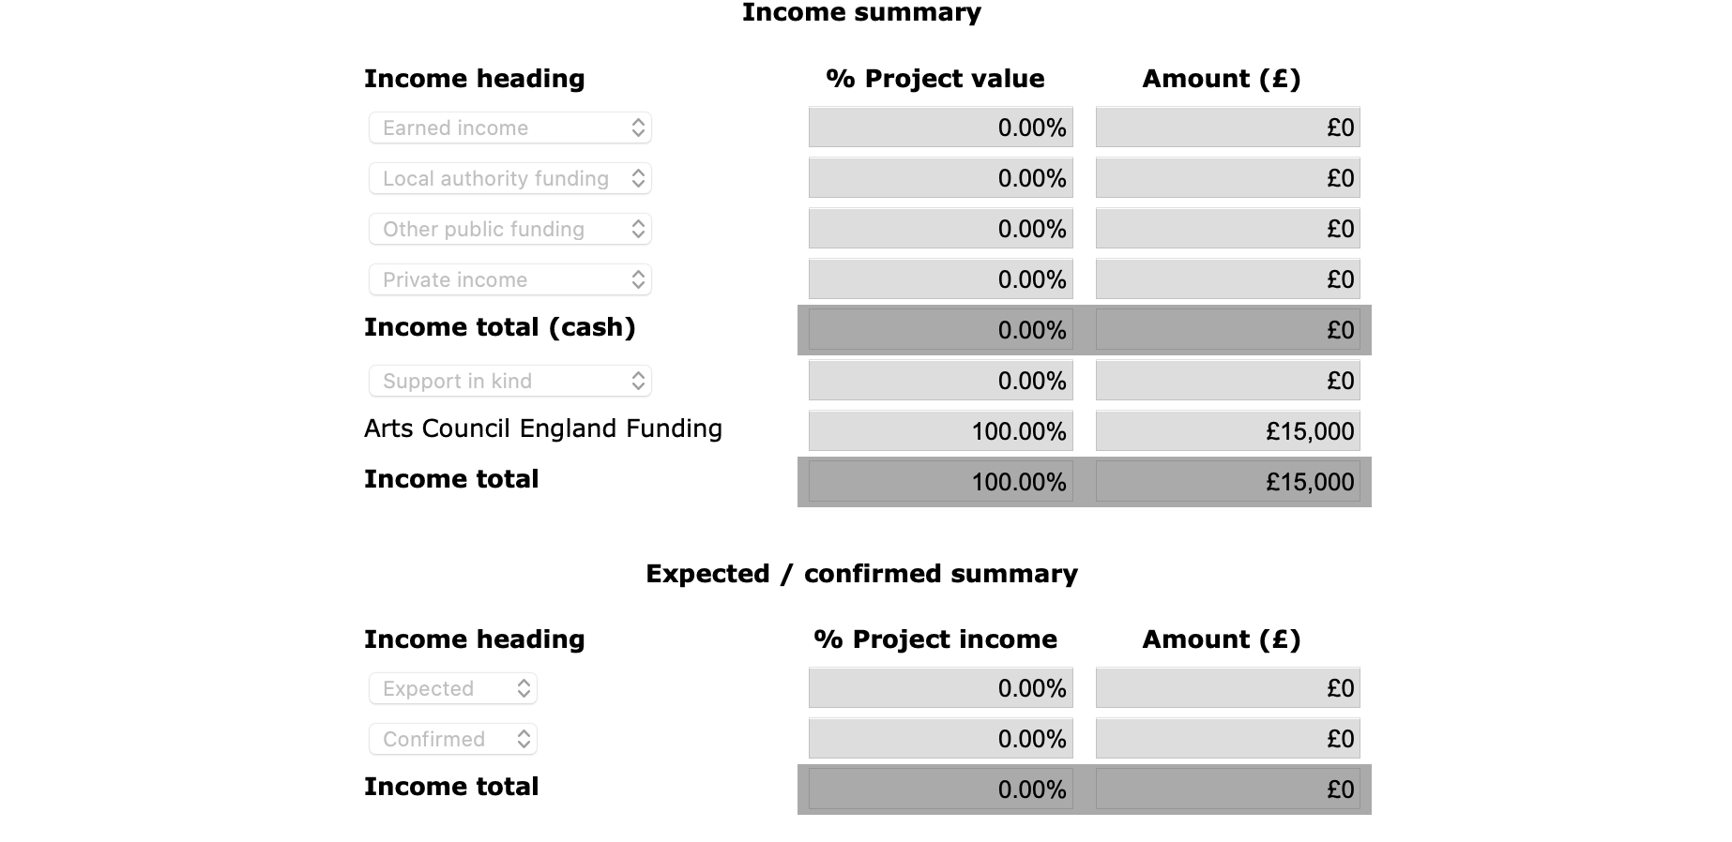

Please tick the box if you have less than 10% funding from sources other than the Arts Council.

Income heading | Description | Expected or confirmed | Amount (£)

FINANCE
INCOME QUESTIONS

* Tell us how you have raised, or plan to raise, the income from other sources you have included in the income table.
This is to help us understand how realistic your budget is, and the partnership support that is in place. Income from other sources could include other grant applications, donations or crowdfunding.

Don’t include any income that won’t be used specifically for this project.

You can use up to 1500 characters to answer this.

*Tell us about the support in kind in your budget
Tell us how you have worked out your support in kind, and why it benefits your project.

You can use up to 1500 characters to answer this.

FINANCE
EXPENDITURE

Please enter all your cash expenditure for your project on this page.

The table at the top of the page is a snapshot of the information you are entering, and will calculate your total expenditure for you as you work. This table is not editable. The table already includes any Support in kind you added on the Income screen so you do not need to add this.

The details about each item of expenditure that you add will be shown in the list at the bottom of the page. You should make sure that you show how your figures have been calculated in the 'Description' field. For example, you should show the number of days and the daily rate for any fees shown.

To add an expenditure line
To add each expenditure line, click the 'Add new item' icon on the left of the screen. To add more than one line of expenditure, use the 'Save and Add another' button.

Screenshot of new table format. Each entry must be categorized as one of the items listed on the left of the table.
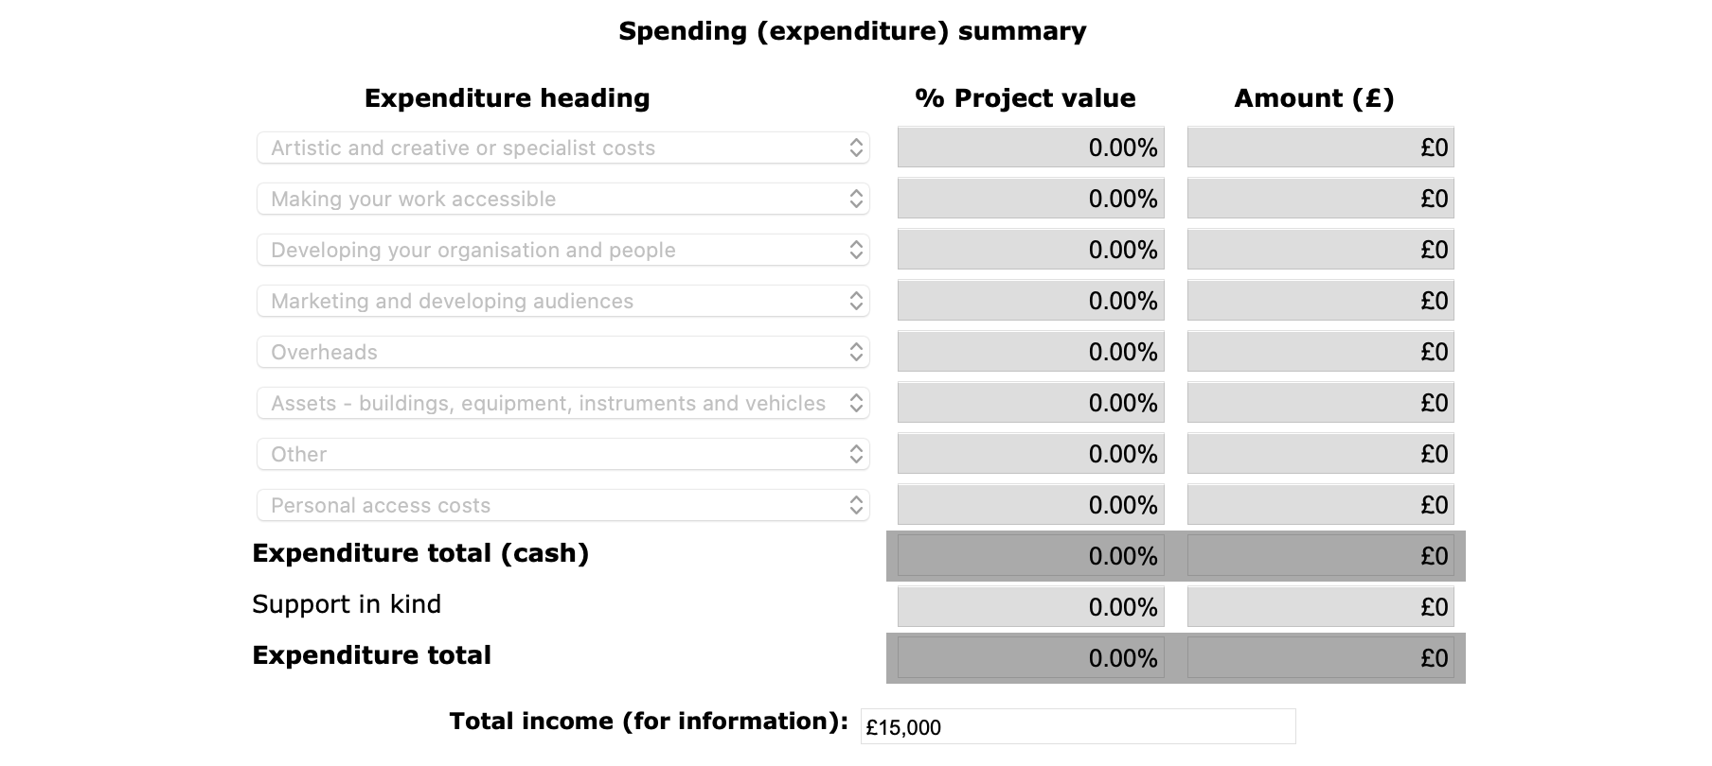

Type of expenditure | Description | Amount (£)

FINANCE
EXPENDITURE QUESTIONS

* Tell us how you will manage the budget for this project, and about your previous experience of managing budgets.
You can use up to 1500 characters to answer this.

* Tell us how you have worked out the costs in your project budget, including the costs of any purchases.
You can use up to 1500 characters to answer this.

FAIR PAY

We are committed to making sure that those who work in arts and culture are properly and fairly paid.

Please read the fair pay section of our How to Apply guidance for more information.

* Have you used any recognised pay guidelines to work out pay for those involved in your project (including you)?

Choose one option that applies from the following list:
Yes – if so, which guidelines have you used?
No, I have calculated fees in a different way

If yes:
Please explain in more detail.
* You can use up to 600 characters to answer this.

If no:
Tell us how you have calculated the fees in your budget.
* You can use up to 600 characters to answer this.

If there are other people included in the delivery of my project, as workers or volunteers, I am aware of my statutory responsibilities.
- Tick box

The latest government guidance on employing people is here.

MANAGEMENT

Management is one of our four criteria.

In this section we want you to tell us how you will manage your project. We will ask you to tell us about any partners involved in the project, where it will be taking place and how you will evaluate the project. We will ask you to fill in a timeline of the key stages of your project, and tell us about the planning you’ve done to date.

Please read the Management section of our How to Apply guidance for help on how to answer these questions.

When we look at your answers to these questions we will think about:
- if the activity is realistic and well planned (including having a realistic tour schedule, where appropriate);
- if the application shows your ability to manage the activity successfully;
- if the team delivering the project has a track record of managing similar activity;
- if the activity is supported by appropriate partnerships; and
- if plans to evaluate the activity are appropriate.

MANAGEMENT
PARTNERS

If you are working with other people or organisations to support the management and/or delivery of your project, we’d like to know about their role and whether their involvement is confirmed.

The table at the bottom of the page will populate with the information you enter about the partners involved in your project.

* Tell us about your, and your partners', recent experience in managing similar types of projects.
You can use up to 1500 characters to answer this.

To add a partner
To add a partner, click the 'Add new item' icon on the left of the screen. To add more than one partner, use the 'Save and Add another' button.

Partner name | Main contact (if organisation) | Email address | Role in project | Confirmed or expected

MANAGEMENT
LOCATION

We are interested in where the projects we support are happening, and whether they involve touring. It’s important for getting a fuller picture about where our investment reaches. We report to our funders on where the activities we fund happen.

Activity that involves touring
A project that includes presenting the same programme of work in a number of different locations.

Activity that doesn’t involve touring
A project that happens in just one place, that happens in several different places but isn’t about touring work, or doesn’t happen in any specific place (for example online work)

Some touring and other types of activity
A project that involves showing the same work in a number of locations, and some work that isn’t touring (eg a tour and some organisational development work).

* Choose:
- focuses on touring
- doesn’t include any touring at all
- includes touring, and other types of activity

Each have follow up data input of venues, local authority, booking status.

MANAGEMENT
ACTIVITY PLAN

* Planning to date
Tell us about the planning and preparation you have already done.

This work should not be included as a cost in your budget; we cannot fund activity that has already taken place.

You can use up to 1500 characters to answer this.

* Project Timeline

Please use the table to list the main stages and tasks of the project from the start date onwards, and to show who will lead on each part of the project.

Enter at least one stage, and add each project stage in order.

To create the table, click the 'Add new item' icon on the left of the screen to add a project stage. To add more than one stage, use the 'Save and Add another' button.

The table at the bottom of the page will populate with the information you enter.

Start date | End date | Activity or task details | Task lead

MANAGEMENT
EVALUATION

Please estimate the results of your project in the categories below. Enter ‘0’ (zero) for any item that is not relevant.

Project results | Estimated
Number of new products or commissions
Period of employment for artists and creatives, or specialists (in days)
Number of performance or exhibition days
Number of sessions for education, training or participation

Divide the day into three sessions (morning, afternoon and evening). A session is any one of these.

* Tell us how you will evaluate your project.
Tell us how you plan to monitor the progress of your project, and evaluate your outcomes throughout the project. Think about all the parts of your project, including quality, public engagement, finance and management. If we give you a grant, we will ask you to evaluate your work and fill in an activity report at the end of your project.

You can use up to 1500 characters to answer this.

MONITORING INFORMATION AND DECLARATION

If you need to update anything in monitoring information – see this guide

Check boxes in declaration, double check the submission summary, sign and submit

ENDS

